**ECEN 714 Lab X**

1. Inverter screenshots

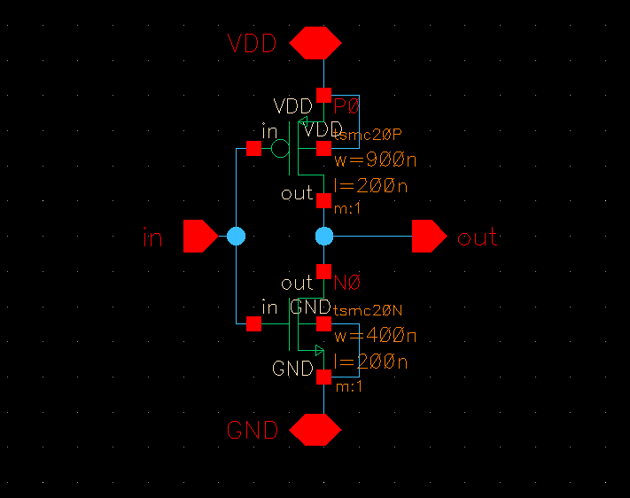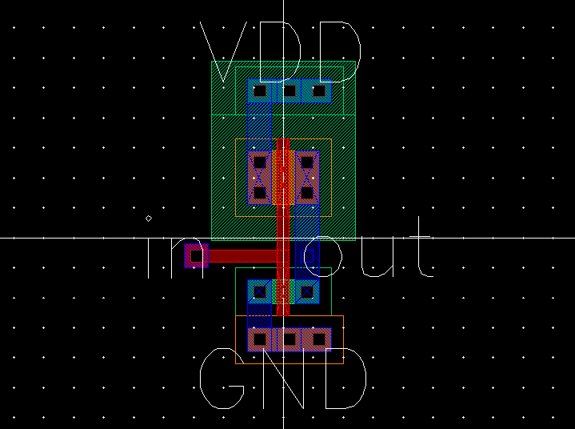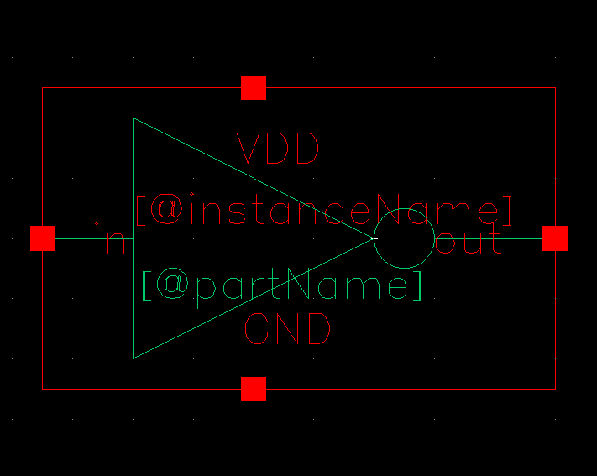

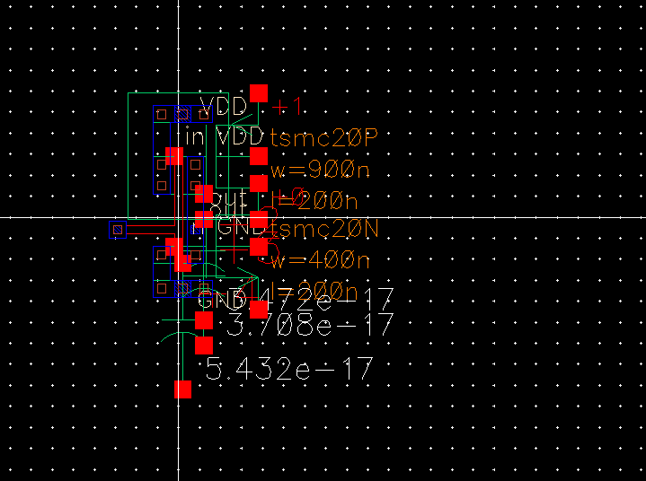

1. Inverter LVS Output

| @(#)$CDS: LVS version 6.1.8-64b 08/04/2020 19:19 (cpgsrv11) $Command line: /opt/coe/cadence/IC618/tools.lnx86/dfII/bin/64bit/LVS -dir /home/grads/a/acoskuner500/ecen714/LVS -l -s -t /home/grads/a/acoskuner500/ecen714/LVS/layout /home/grads/a/acoskuner500/ecen714/LVS/schematicLike matching is enabled.Net swapping is enabled.Using terminal names as correspondence points.Compiling Diva LVS rules... Net-list summary for /home/grads/a/acoskuner500/ecen714/LVS/layout/netlist count 4 nets 4 terminals 1 pmos 1 nmos Net-list summary for /home/grads/a/acoskuner500/ecen714/LVS/schematic/netlist count 4 nets 4 terminals 1 pmos 1 nmos Terminal correspondence points N0 N3 GND N3 N1 VDD N2 N2 in N1 N0 outDevices in the netlist but not in the rules: pcapacitorDevices in the rules but not in the netlist: cap nfet pfet nmos4 pmos4The net-lists match. layout schematic instances un-matched 0 0 rewired 0 0 size errors 0 0 pruned 0 0 active 2 2 total 2 2 nets un-matched 0 0 merged 0 0 pruned 0 0 active 4 4 total 4 4 terminals un-matched 0 0 matched but different type 0 0 total 4 4Probe files from /home/grads/a/acoskuner500/ecen714/LVS/schematicdevbad.out:netbad.out:mergenet.out:termbad.out:prunenet.out:prunedev.out:audit.out:Probe files from /home/grads/a/acoskuner500/ecen714/LVS/layoutdevbad.out:netbad.out:mergenet.out:termbad.out:prunenet.out:prunedev.out:audit.out: |
| --- |

1. NAND2 screenshots

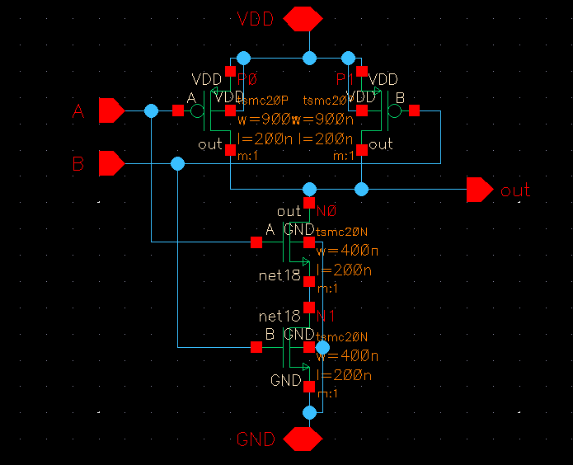

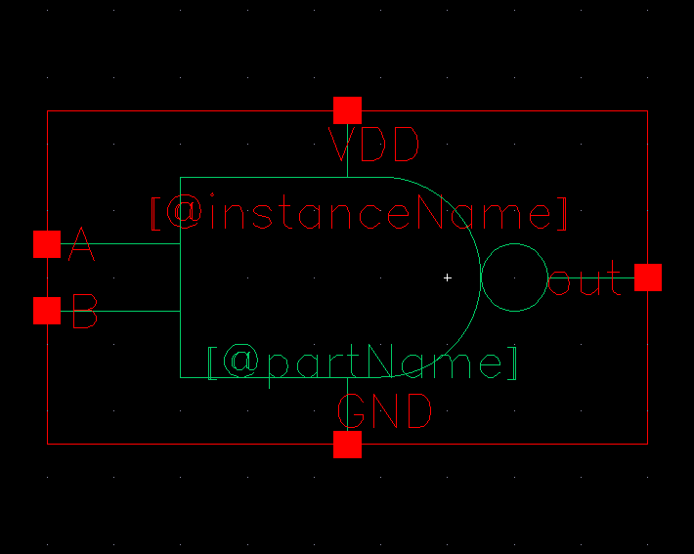

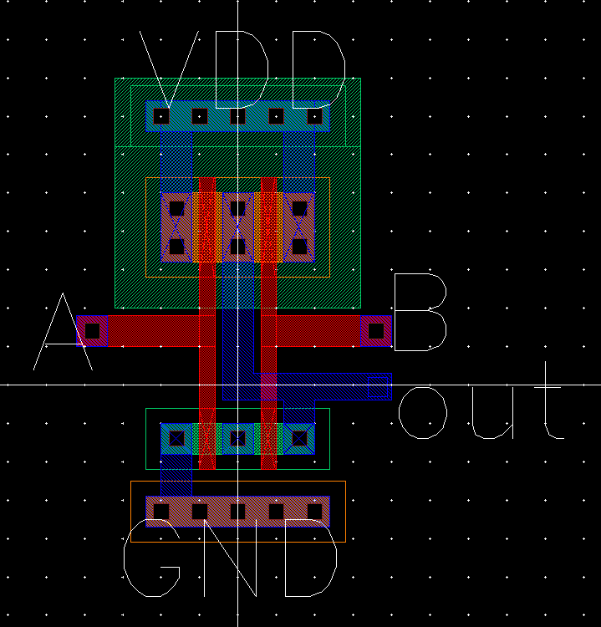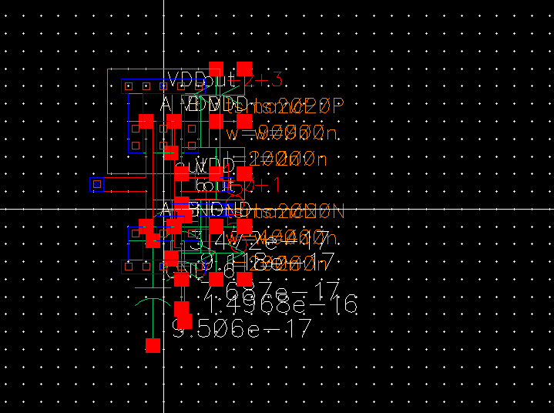

1. NAND2 LVS Output

| @(#)$CDS: LVS version 6.1.8-64b 08/04/2020 19:19 (cpgsrv11) $Command line: /opt/coe/cadence/IC618/tools.lnx86/dfII/bin/64bit/LVS -dir /home/grads/a/acoskuner500/ecen714/LVS -l -s -t /home/grads/a/acoskuner500/ecen714/LVS/layout /home/grads/a/acoskuner500/ecen714/LVS/schematicLike matching is enabled.Net swapping is enabled.Using terminal names as correspondence points.Compiling Diva LVS rules... Net-list summary for /home/grads/a/acoskuner500/ecen714/LVS/layout/netlist count 6 nets 5 terminals 2 pmos 2 nmos Net-list summary for /home/grads/a/acoskuner500/ecen714/LVS/schematic/netlist count 6 nets 5 terminals 2 pmos 2 nmos Terminal correspondence points N3 N1 A N2 N0 B N1 N3 GND N5 N2 VDD N4 N4 outDevices in the netlist but not in the rules: pcapacitorDevices in the rules but not in the netlist: cap nfet pfet nmos4 pmos4The net-lists match. layout schematic instances un-matched 0 0 rewired 0 0 size errors 0 0 pruned 0 0 active 4 4 total 4 4 nets un-matched 0 0 merged 0 0 pruned 0 0 active 6 6 total 6 6 terminals un-matched 0 0 matched but different type 0 0 total 5 5Probe files from /home/grads/a/acoskuner500/ecen714/LVS/schematicdevbad.out:netbad.out:mergenet.out:termbad.out:prunenet.out:prunedev.out:audit.out:Probe files from /home/grads/a/acoskuner500/ecen714/LVS/layoutdevbad.out:netbad.out:mergenet.out:termbad.out:prunenet.out:prunedev.out:audit.out:@(#)$CDS: LVS version 6.1.8-64b 08/04/2020 19:19 (cpgsrv11) $Command line: /opt/coe/cadence/IC618/tools.lnx86/dfII/bin/64bit/LVS -dir /home/grads/a/acoskuner500/ecen714/LVS -l -s -t /home/grads/a/acoskuner500/ecen714/LVS/layout /home/grads/a/acoskuner500/ecen714/LVS/schematicLike matching is enabled.Net swapping is enabled.Using terminal names as correspondence points.Compiling Diva LVS rules... Net-list summary for /home/grads/a/acoskuner500/ecen714/LVS/layout/netlist count 6 nets 5 terminals 2 pmos 2 nmos Net-list summary for /home/grads/a/acoskuner500/ecen714/LVS/schematic/netlist count 6 nets 5 terminals 2 pmos 2 nmos Terminal correspondence points N3 N1 A N2 N0 B N1 N3 GND N5 N2 VDD N4 N4 outDevices in the netlist but not in the rules: pcapacitorDevices in the rules but not in the netlist: cap nfet pfet nmos4 pmos4The net-lists match. layout schematic instances un-matched 0 0 rewired 0 0 size errors 0 0 pruned 0 0 active 4 4 total 4 4 nets un-matched 0 0 merged 0 0 pruned 0 0 active 6 6 total 6 6 terminals un-matched 0 0 matched but different type 0 0 total 5 5Probe files from /home/grads/a/acoskuner500/ecen714/LVS/schematicdevbad.out:netbad.out:mergenet.out:termbad.out:prunenet.out:prunedev.out:audit.out:Probe files from /home/grads/a/acoskuner500/ecen714/LVS/layoutdevbad.out:netbad.out:mergenet.out:termbad.out:prunenet.out:prunedev.out:audit.out: |
| --- |

1. XOR2 Screenshots

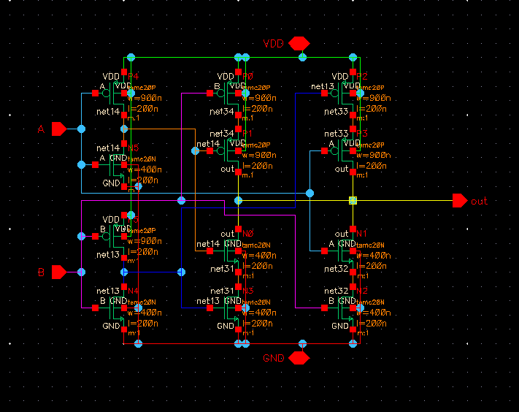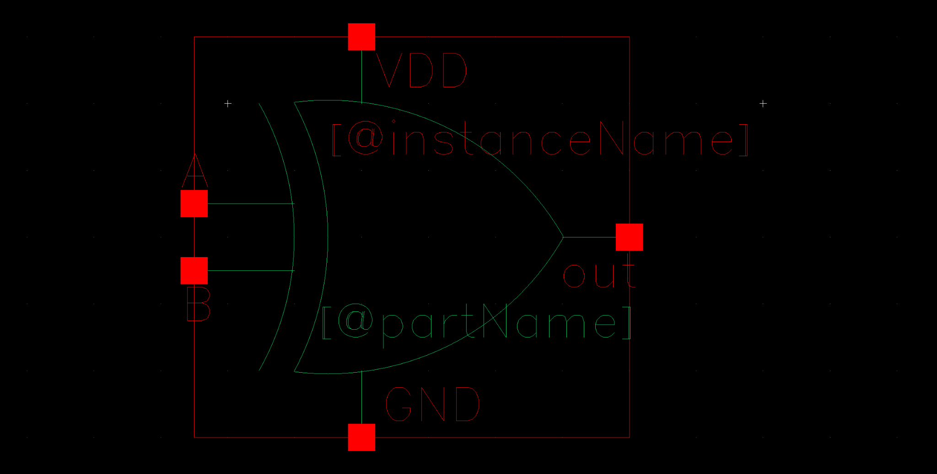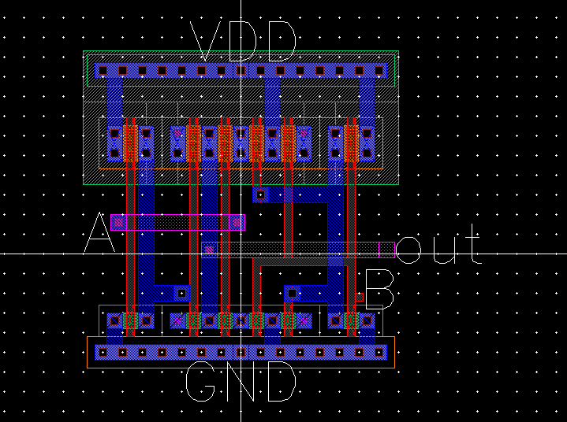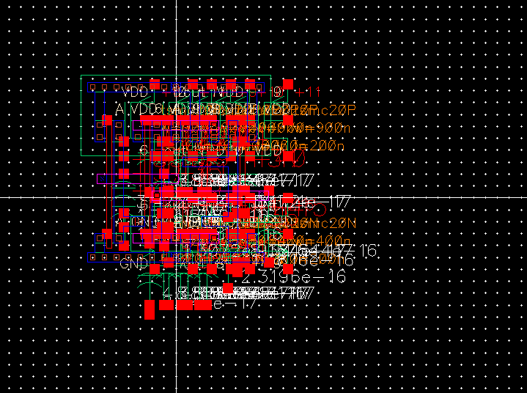

1. XOR2 LVS Output

| @(#)$CDS: LVS version 6.1.8-64b 08/04/2020 19:19 (cpgsrv11) $Command line: /opt/coe/cadence/IC618/tools.lnx86/dfII/bin/64bit/LVS -dir /home/grads/a/acoskuner500/ecen714/LVS -l -s -t /home/grads/a/acoskuner500/ecen714/LVS/layout /home/grads/a/acoskuner500/ecen714/LVS/schematicLike matching is enabled.Net swapping is enabled.Using terminal names as correspondence points.Compiling Diva LVS rules... Net-list summary for /home/grads/a/acoskuner500/ecen714/LVS/layout/netlist count 11 nets 5 terminals 6 pmos 6 nmos Net-list summary for /home/grads/a/acoskuner500/ecen714/LVS/schematic/netlist count 11 nets 5 terminals 6 pmos 6 nmos Terminal correspondence points N8 N8 A N7 N6 B N6 N2 GND N10 N0 VDD N9 N1 outDevices in the netlist but not in the rules: pcapacitorDevices in the rules but not in the netlist: cap nfet pfet nmos4 pmos4The net-lists match. layout schematic instances un-matched 0 0 rewired 0 0 size errors 0 0 pruned 0 0 active 12 12 total 12 12 nets un-matched 0 0 merged 0 0 pruned 0 0 active 11 11 total 11 11 terminals un-matched 0 0 matched but different type 0 0 total 5 5Probe files from /home/grads/a/acoskuner500/ecen714/LVS/schematicdevbad.out:netbad.out:mergenet.out:termbad.out:prunenet.out:prunedev.out:audit.out:Probe files from /home/grads/a/acoskuner500/ecen714/LVS/layoutdevbad.out:netbad.out:mergenet.out:termbad.out:prunenet.out:prunedev.out:audit.out: |
| --- |